Distorting 3D Space-Time to Fit Comic Narratives

|  |  |
| --- | --- |
| Antoni B. Moore*  University of Otago, New Zealand | David O’Sullivan†  University of Auckland, New Zealand |

Abstract

This research describes a modification on a technique that inserts comic strip stories into 3D space-time visualisations, enabled by the matched linearity of the strip with the plotted line in a map and spatiotemporal content. The unevenness (structure, pacing) of a story is addressed by distorting (Euclidean) space and time to accommodate it. For example, a part of the narrative where a lot happens in a small area of space and/or time is feature-rich, leading to expansion of space-time, and vice versa. An individual ‘working day’ example is presented, with future potential development discussed.

**Index terms**: comic strip, 3D cartogram, space-time narrative.

# Introduction

The inner lives of humans are able to be mapped like never before, enabled by enhanced spatial data collection and dissemination means. Along with research and professional initiatives to develop hybrid art and cartography approaches [1], this marks a type of spatial representation that conveys ‘emotional’ content to complement the predominant scientific basis in maps. In geographic terms, maps of personal place are being added to impersonal ‘space’-based maps. On aspect of art is how to represent stories or narrative. <more on vis approaches to narrative - Heer [2]> In a cartographic context, this has already been explored in cinematic and fine art media i.e. maps and stories are now frequently found together [3]. Sequential art (comic strips and graphic novels) [4] has already been explored in a data visualisation sense <expand on ‘Data Comics’> [5].

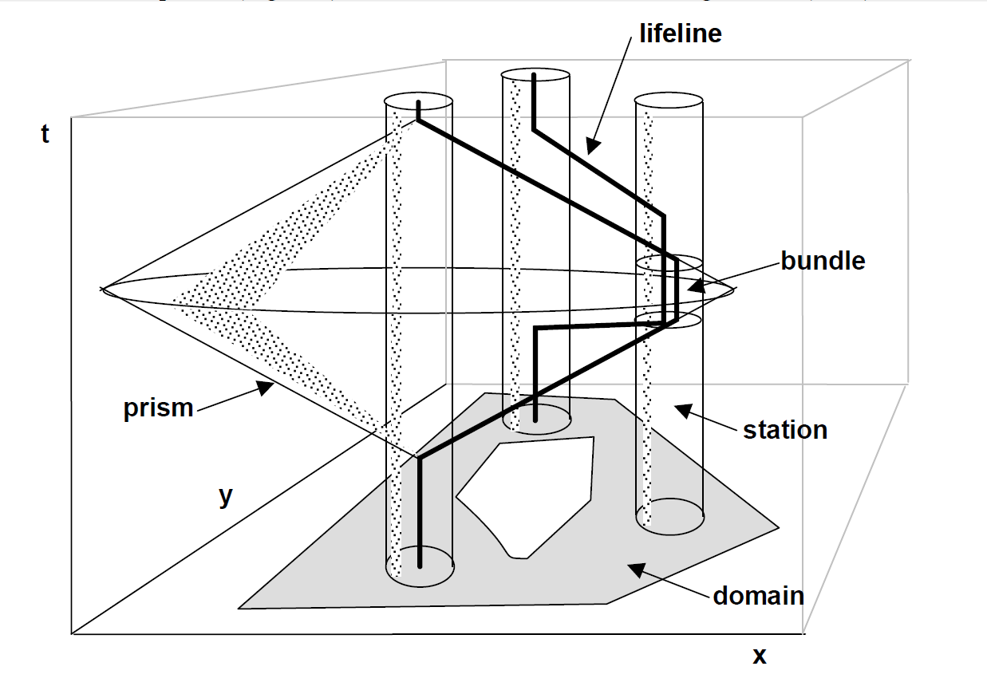

1. The Space-Time Cube [7]. <bundles, stations etc.>

* e-mail: tony.moore@otago.ac.nz

† e-mail: osullivan512@gmail.com

Fundamentally, they have the desirable property of forcing space-time narrative into a structure that makes it more compatible with maps. This is especially true if the traditional page format of such media is relaxed and the strip is allowed to be a line, as is the case with some digital comic strips.

# Comic strips and the space-time cube

Moore et al. [6] explores the shared linearity of the comic strip and the line in the map, with comic strip frames located at the geographic coordinates of that part of the narrative. With the tendency towards unreadability and excess complexity when limited to an XYT space, an XYT space (or space-time cube – Figure 1 [7]) was implemented as the container for the narrative, the 3rd dimension able to separate co-located parts of the narrative occurring at different times. In this implementation, the implicit space-time footprints in stories are captured by a generalized XYT line (the ‘lifeline’ in Time Geography speak), able to ‘mount’ comic frames (Figure 2). Conventions of reading were also explored, there is an expectation of reading the story from top to bottom, like a book.

# The unevenness of narrative

This research addresses one of the issues raised in [6], that narrative is not usually evenly distributed in space and time. Comic strip frames are only found in certain XYT locations – there will be spaces and / or times in which a lot of narrative happens, and vice versa. In order to maintain legibility, linear and rhythmic narrative, space and time in the space-time cube will be variably distorted to fit the comic frame narrative (Figure 3). In other words, the conventional single-scale map is replaced with a multi-scale approach.

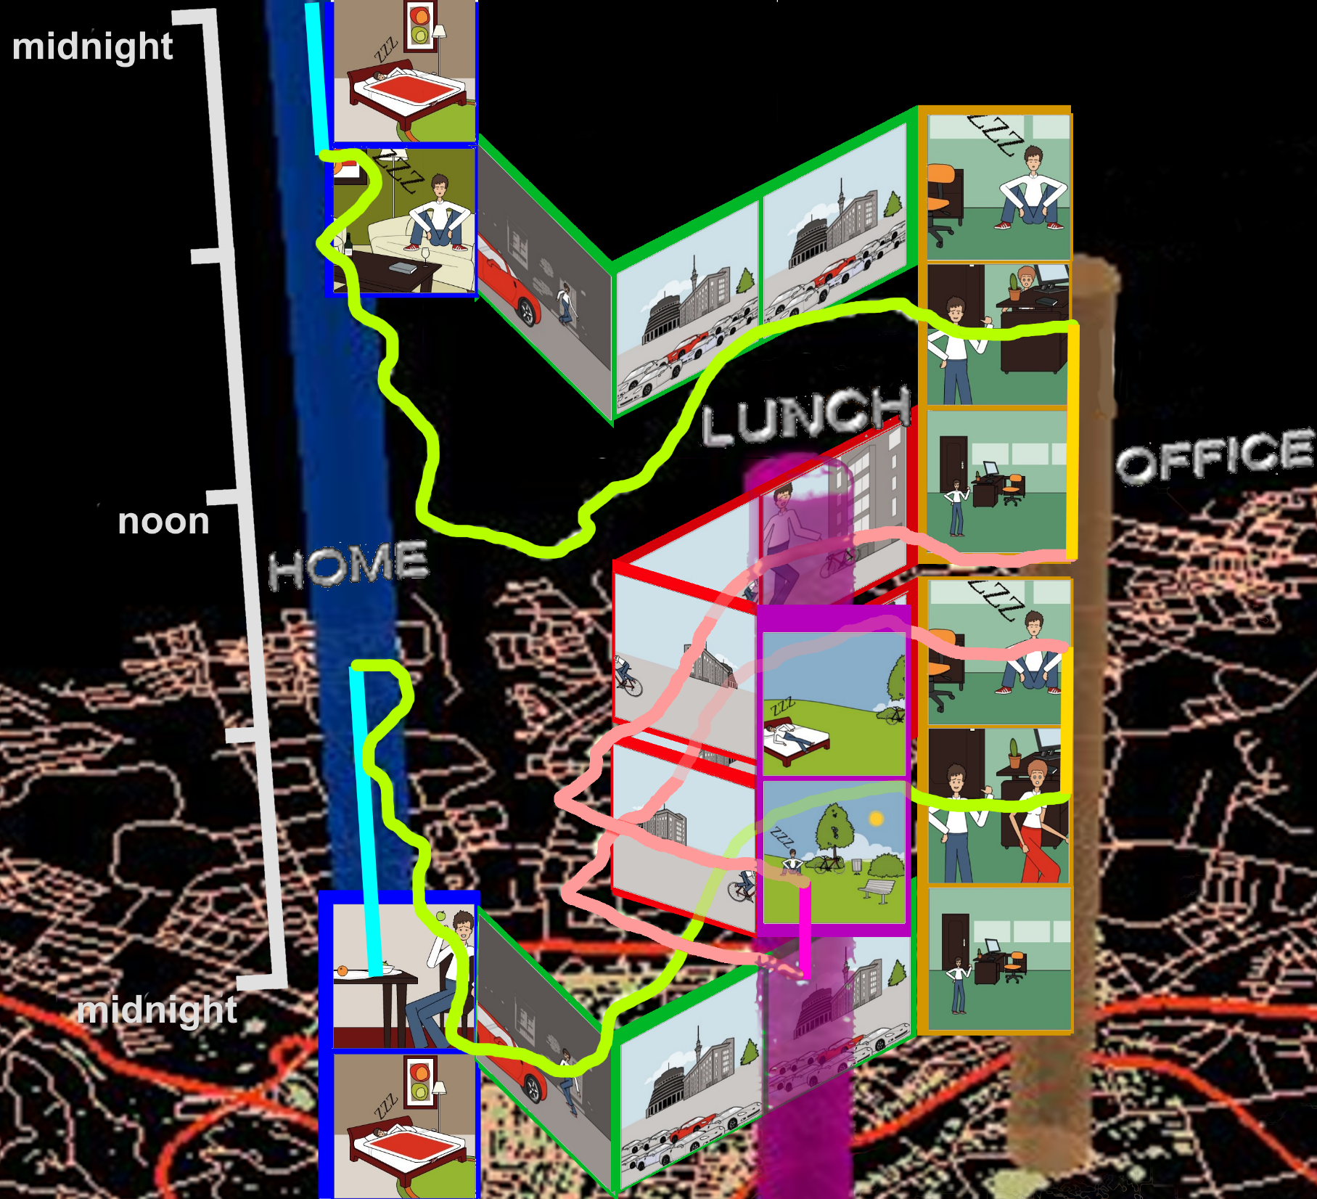<other solutions include Caquard and Fiset [8], McCloud [4]>

1. A ‘working day’ comic strip in a space-time cube [6].

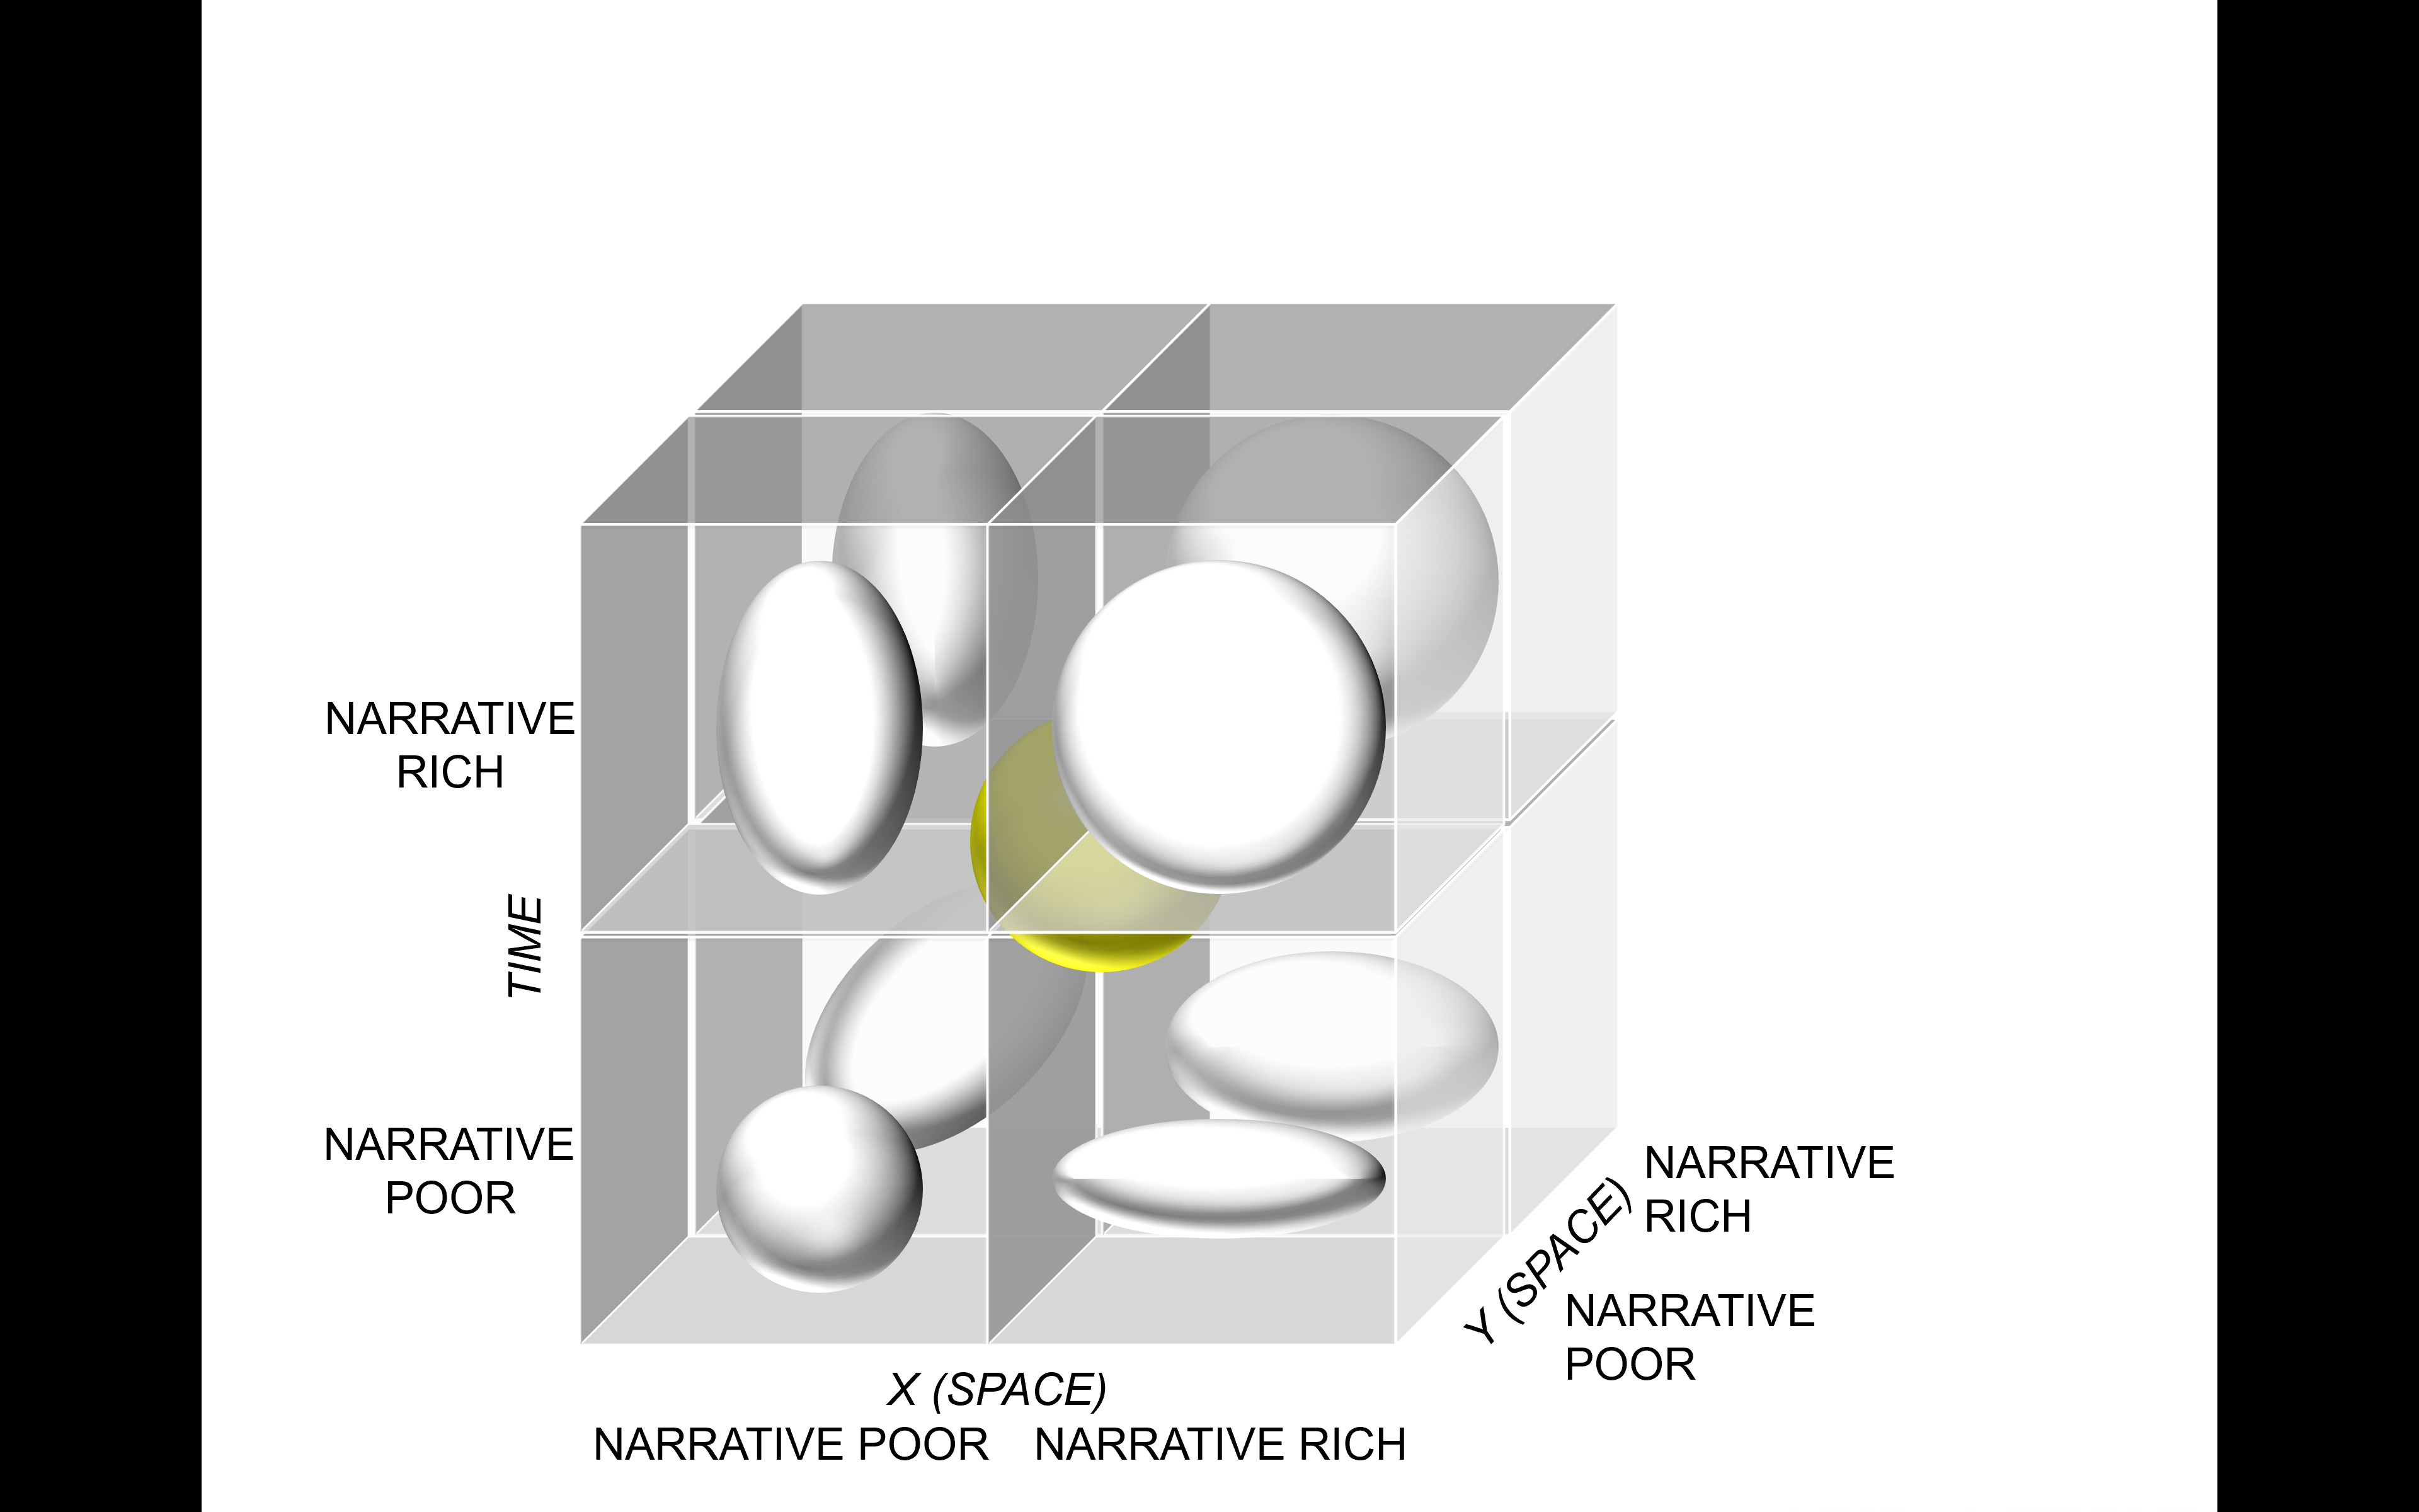

1. Schematic of distortion in space and/or time due to narrative. The non-transformed yellow sphere represents a situation where narrative fits undistorted space and time perfectly.

# Proposed solution and implementation

The solution is in effect a 3D cartogram, where area in the map is proportional to an attribute other than geometric area (or in a 3D sense, volume). A logarithmic projection would achieve a similar yet global effect. As such, the method used emulates cartogram generation algorithms (e.g. Gastner and Newman [9]), with narrative (i.e. comic frame) density driving volume. In a NetLogo 3D environment, a simple XYT text file defining a generalised path through time-space (a simple working day, as in Figure 2), with 3D locations of comic frames en route was used to calculate the narrative denisty with which to distort space-time. 3D space-time in the development environment is filled with a voxel lattice that is subject to a diffusion function in the vicinity of narrative XYT points. Weights of diffusion are spread from the enclosing voxel to its neighbours, expanding space and timewhere the narrative is. The entire development space is surrounded by a buffer volume, so that accumulated expansion is kept within finite 3D limitations of the development environment (Figure 4).

<use of turtles for comic strip; cartographic treatment of lines; effects of differential expansion and contraction>

1. Comic strip lifeline in distorted space-time <placeholder>

# Future Directions and Concluding Thoughts

We’ve seen how transferring narrative to a space-time map is not straightforward. Beyond the presented solution that addresses a multi-scale aspect, other properties of narrative need to be tackled: imprecision and vagueness of geographical evidence that allows mapping (not to mention fiction – non-fiction), and the spatiotemporal complexity of protagonists in stories. While enabling (simultaneous representation of multiple timelines, forking), many timelines would be a challenge. Solutions might lie in Time Geography (aggregation of multiple timelines into a single bundle) or bringing in user interactivity to actively simplify the situations (environments such as Marimo facilitates dissemination too). Narrative detail could be linked to degree of zoom (McCloud explores the telling of stories to multiple degrees of efficiency), and slicing / selection and projection functionality could be introduced.

<rigorous and structured testing linked to the situations in Fig 3>

<more critical applications: climate change, env. Health linked to the accessibility of the comic strip>

# References

1. Robinson et al 2017
2. Heer.
3. One maps and stories reference.
4. McCloud
5. Data Comics.
6. Moore et al
7. Hagerstrand or Kraak.
8. Caquard and Fiset.
9. Gastner and Newman